# Sun Shader 1.1 Manual

Designed by Panteleymonov Aleksandr 2016

## About

It is a simple procedural generator of sun of some rays star. The peculiarity of the use of this Shader is completely generated by the content without using additional resources. But the full synthesis is a demanding task, also added a variant using static synthesized 3D texture. It is available only for the Pro version of unity 4. Full functionality is available for Unity5.

## How to use

A quick way to create a model using a Shader to apply the script to an empty GameObject "Component/Space/Star/SunGenerator”. You can also use any of the materials in Examples on any object appropriate for the parameters of radius. For the completely manual creation use the appropriate Shader "Space/Star" while creating material.

In any case the model is created you can see a set of options which can be fully customized to feature your visual stars.

### Mode Shader

Specifies the Shader model to be used to generate the stars.

* SM4 - is a fully synthesized the star in real time, requires a lot of resources performance.
* SM3 - a simplified model for low-end devices, but also requires a lot of resources performance.
* CPU_SM4 - version with low resource consumption using static texture.
* CPU_SM3 - for low-end devices, uses a static texture.
* LIGHT_SM4 - it is a simplified version of the Shader rays and body which are synthesized together.
* LIGHT_SM3 - an even more simplified light version.
* LIGHT_CPU - also option allowing to use a texture synthesis noise.

### Mesh Type

This is an automatically generated surface on which to display the object. Really, you can use the surface of any shape, but in proportion to the total radius of the object.

* Billboard – simple surface allows you to display the model star at a great distance from the camera. If you place an object too close the edges will be cut.



* Prisma - more complicated surface covering the visual range of the Star.

If you use any non-standard surface such as a cylinder, without using a script - using the material, you will notice that it will automatically rotate to the camera, and all of its basic geometry settings will be reset, in addition to Transform-Scale, so you can set it to the desired size.



### Radius, Ray String and Zoom

Three parameters specify the relative dimension of the model. Their combination allows you to set the basic shape.

* Radius sets the amount of material mass of the star.
* Combination with Zoom will allow you to increase or decrease the number of parts.
* Ray String - the space around the stars covered by the rays.

From left to right: big Ray String, all Medium, big Radius.



You will notice that if you increase the Radius and decrease the Zoom on the surface, there will be more details, but the overall size will not be changed.

### Detail and Seed

Depending on model the Shader quality of detail can vary. The basic range is from 1 to 6. If you use 0 it will be black hole.



Seed – the uniqueness of the model was generated.

### Glow, Rays, Ray Ring and Ray Glow

The four parameters specifying the glow around the body of the star.

* Glow is the intensity of illumination around the body, 0 is a reasonable maximum, but you can use negative values.
* Rays - sets the contrast of the rays at the surface, also negative values make a big contrast.



* Ray Glow also sets the contrast of the rays but at the end of the rays.
* Ray Ring - creates a beam of rays.



### Colors

Four colors define the surface, and two rays.

* Light - is the most vivid color of the surface.
* Color - is the primary color.
* Base color - the color of the soil.
* Dark color - the cooling elements.
* Ray Light - color illumination rays.
* Ray Color - color of rays.

### Animation

You can set the animation speed of certain elements.

* Speed Low - is the speed the smallest detail which can only be seen at very high quality.
* Speed Hig - is the speed of the main body elements of the star.
* Speed Ray - specifies the jitter radiation.
* Speed Ring - speed bursts of rays.

### Noise Generator

The construction of the surface of the object and rays is based on a combination of several noise fields. Each field is a layer of detail which is set with its brightness and scale of elements. Each implementation has a different number of layers, which are divided into four groups, for which you can set their parameters. To the surface of the object is set to the brightness and scale, for the rays the scale.

For example you can take any noised image, and zoom it on 800%, 400%, 200% and 100% in any image editor like photoshop.

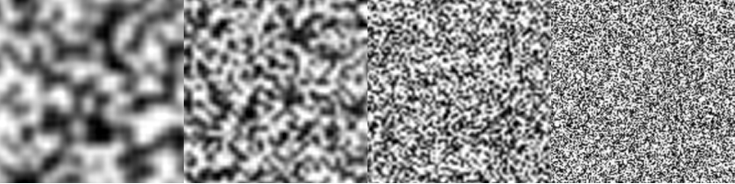

This would be equivalent to Body Noise Scale (1.0, 2.0, 4.0, 8.0). But if you fold these layers the result will be overexposed. Now if you set the brightness for each layer to 25%, Body Noise Light (0.15, 0.15, 0.15, 0.15). When adding such images will get the result:

 

While experimenting with the brightness you can get more expressive form Body Noise Light (0.05, 0.1, 0.25, 0.3):

 

This is the basis for modeling the object's surface, For modeling rays brightness is settable control elements (Rays, Ray Ring and Ray Glow), this is only used scaling layers. The equivalent proportions for the rays Ray Noise Scale (1.0, 2.0, 2.0, 2.0)